BUKTI KORESPONDENSI
JOURNAL OF CONTEMPORARY ISSU BUSINESS AND GOVERNMENT

1. Bukti Sumbit Paper
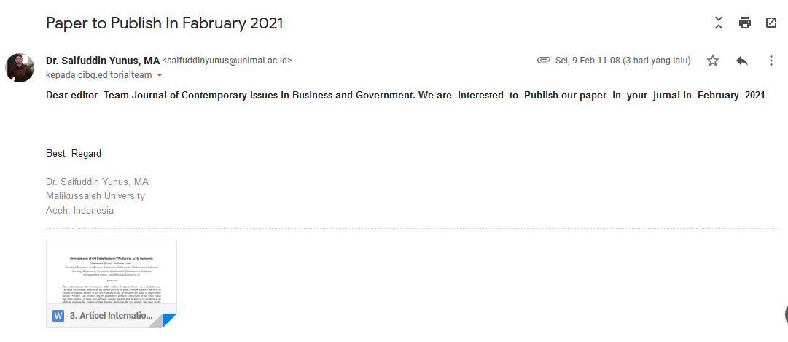

2. Paper Yang perlu direvisi
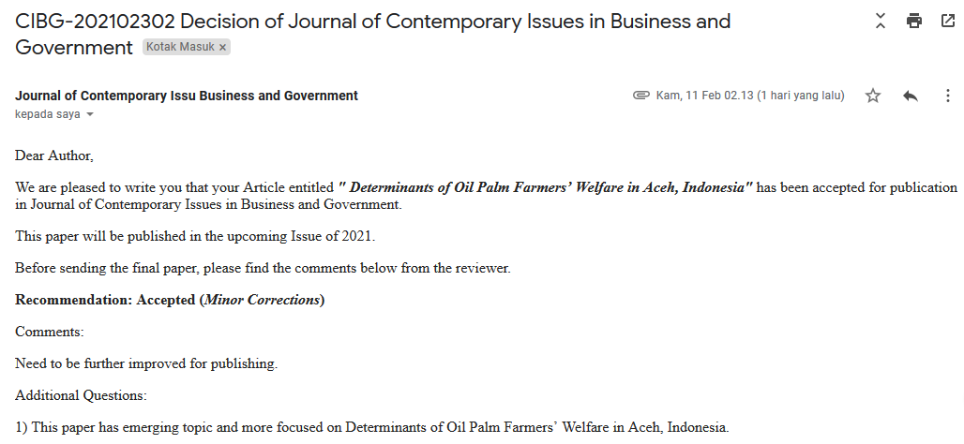
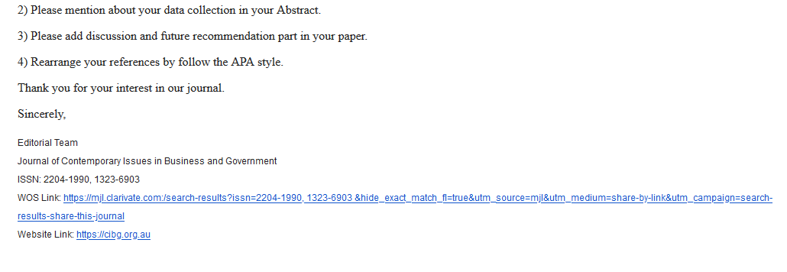
3. Pengiriman Paper Setelah Revisi
Paper ID: CIBG-202102302. Paper Title: Determinants of Oil Palm Farmers’ Welfare in Aceh,Indonesia. Author: Muhammad Haykal, Saifuddin Yunus
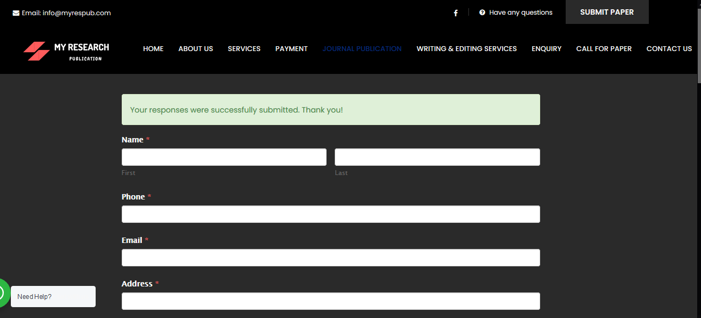

4. Letter of Acceptance and Invoice
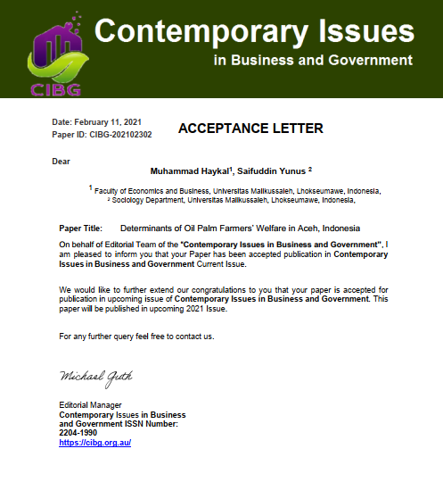
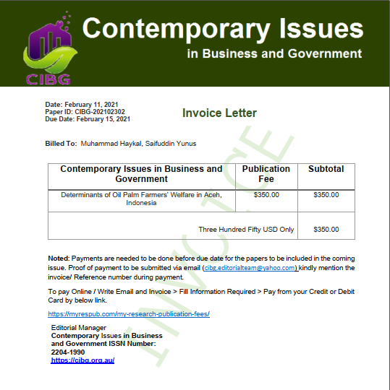

4. Proff of Paymant 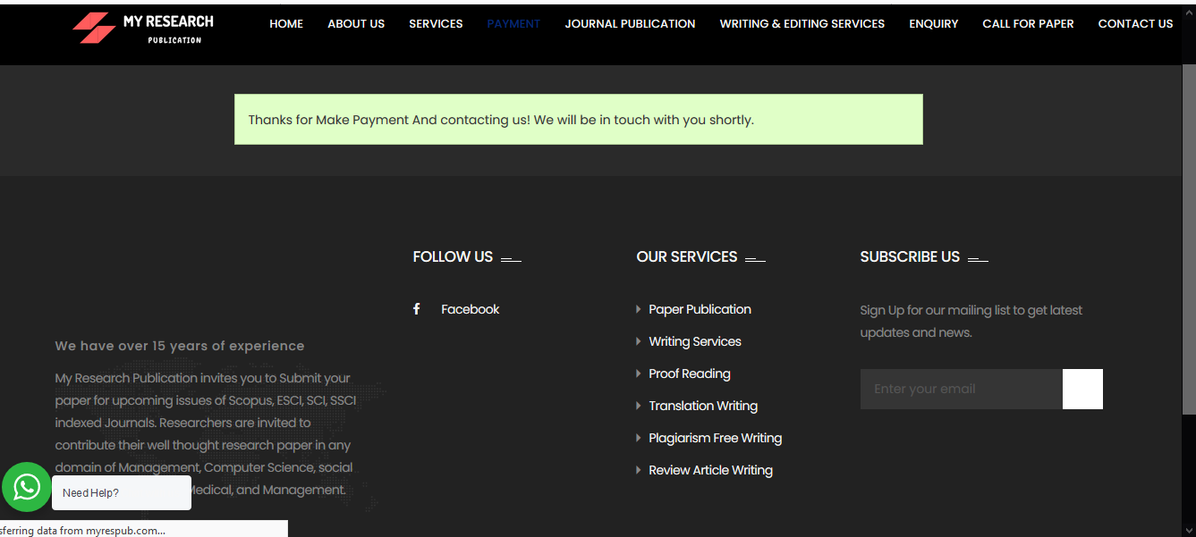

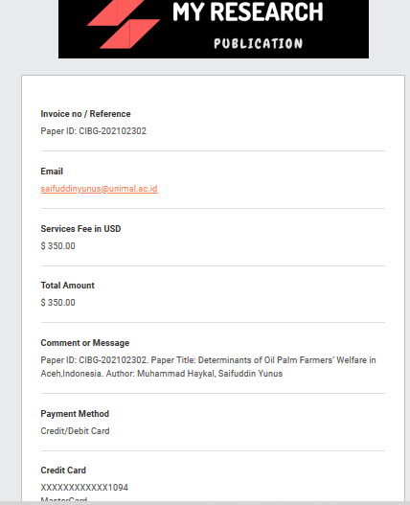

6. Bukti Pembayaran diterima
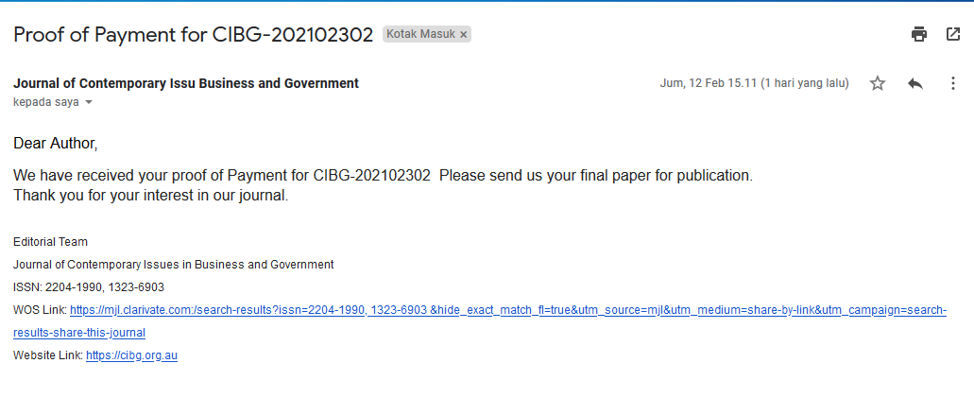

7. Artikel Revisi Terakhir Untuk Publikasi

